First Time Login:

Your new user account login ID was established with the email address you provided on your application.

You will create a password for this site on your initial login. Due to HIPAA regulations a two-step authentication process will be required. You will be prompted to provide a land line or cell phone for this two-step verification process. There are two options available, a phone call or text message. Follow the instructions and choose your options and phone number. Take care to enter phone numbers correctly.
For easy access, use the links below to access the Data Submission System, and create a shortcut or add to your browser favorites.
- IL-Administrator-Data Submission Home Page
- MT-Administrative-Data Submission Home Page

On each login, you will be prompted to request a verification code or phone call based on your initial setup.

Note: Before you begin, see Email Notice below and have your IT department complete this step prior to accessing the reporting system.

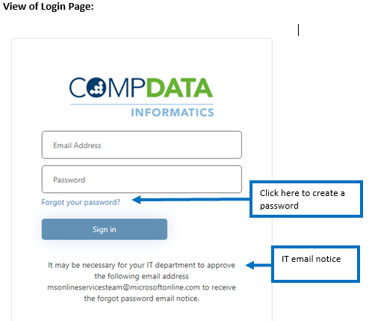

Change Password

Passwords must be changed every 90 days. The user will receive a notification upon signing into the system beginning at 10 days until expiration.
If you exceed the maximum number of login attempts or the number of text messages and is locked out of the system, log out and the system will unlock after 30 minutes. If you forgot your password, please utilize the “Forgot Password” feature on the login page (see above) to reset your password.

Password resets are only available via the “Forgot Password” link. The COMPdata support services are not able to reset passwods manually due to the Multifactor Authentication (MFA) feature.

Passwords must be a minimum of 12 characters long and contain 3 of upper case letters, lower case letters, number or a specific character (!, #, $, or @). The password cannot contain any 3 consecutive characters that are also in the username.

Account Updates

To make changes to existing phone numbers, or emails please complete the Update My Account Information form. Email updates will require you to complete the setup information again for the MFA for your new login.

