 Case Counts Entry Job Aid

Accessing the System:

- Click on https://www.compdatainfo.com/Home.aspx
- Click on 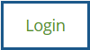
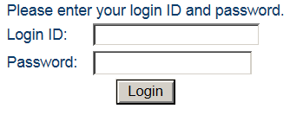
Click on “Login” after entering your login ID and password

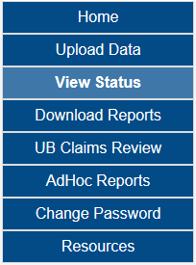
Click here

Enter Case Counts

Use the drop down arrows to select your facility if you report for more than one
Enter your monthly case counts/discharges then click on “Save”

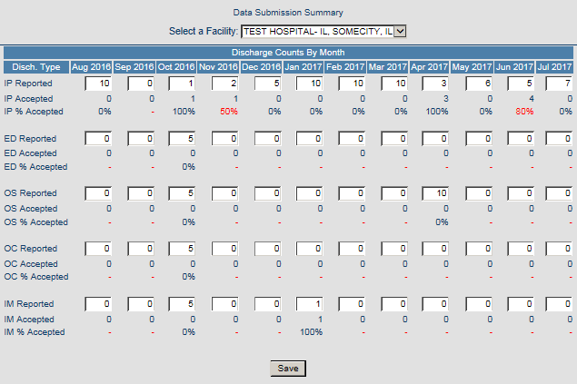
Click here

What are Case Counts?

- Case counts are calculated numeric figures representing patients’ volume each month.
- The case count is entered in the system as the benchmark for how many discharges you say you had each month.

Why Entering Monthly Discharges Volume is Important?

- Required/mandated actions to meet the minimum compliance level by month/quarter.
- Illinois Hospitals and ASTCs = 98%
- Montana Hospitals = 90%
- Complete quarterly/yearly Data Submission Verification Report (DSVR).
- The DSVR/DQSR is provided to the Illinois Department of Public Health (IDPH) and Montana Hospital Association and is reviewed for compliance levels.

