 Create AdHoc Reports Job Aid

Accessing the System:

- Click on https://www.compdatainfo.com/Home.aspx
- Click on 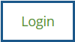
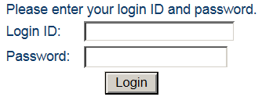
Click on “Login” after entering your login ID and password

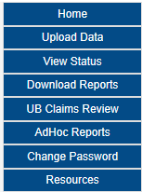
Click here

Error Free AdHoc Report

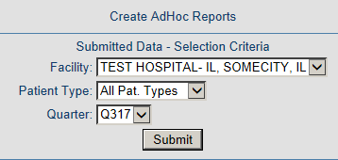
Click here
Use the drop down arrows to:

- Select your facility if you report for more than one
- Select the patient type
- Select the quarter

You will receive a job number after you click on Submit:

Allow a few minutes for your report to process then Click on:

You can identify your report by job number, quarter, submitted date and time:

Error AdHoc Report
Use the drop down arrows to:
- Select your facility
- Select your quarter
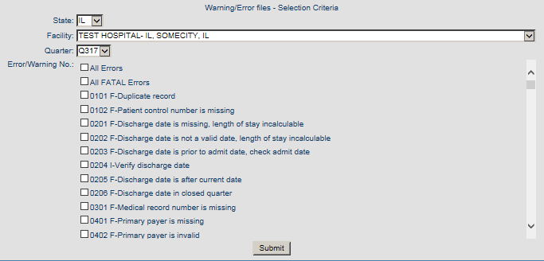
Click here
Click on the box to select:
- All Errors
- All Fatal Errors or
- Individual error numbers

You will receive a job number after you click on Submit:

Allow a few minutes for your report to process then Click on:

You can identify your report by job number, quarter, submitted date and time:

All AdHoc reports are in an Excel spreadsheet.

AdHoc reports can be created for production submissions only.

